Draft Minutes of Coldridge Parish Council Meeting 19.00 on Wednesday 4th February 2026
Present: Councillors John Smith, (Acting Chairman) Marion Born, John Quick (19.25) Malcolm Bedford, Chris Burrows & Ivan Kriznik.
Clerk Keyth Richardson
Apologies: Cllr Andrew Green

Minute ref | topic | details | Action
2025/6-73 | Welcome by Chairman | John Smith welcomed all to the meeting, including a member of the public
2025/6-74 | Recording of meetings | no-one was recording the meeting
2025/6-75 | Apologies | Andrew Green
2025/6-76 | Declarations of interest | none
2025/6-77 | Planning | 25/00547/FULL C&R Construction.  This meeting was solely to review the current situation, the three previous comments made by the Parish Council in April, May and September 2025, and the findings of a site visit in January 2026  After some discussion the following was agreed as a comment to be posted on the MDDC Panning portal.  Coldridge Parish Council stand by all their previous comments dated 15th April, 21st May and 18th September 2025.  The fundamental concern is that the office block is in the wrong location, and no amount of screening will resolve this.  The Planning Application is still not compliant with DM1, S14 and DM27, especially with regard to the incongruity of the office block with its surroundings in a rural location, and the invasion of neighbour’s privacy. It is in full view of the properties in Mount Evelyn and overlooks 2 properties to the north.  The containers which are meant to have been moved as part of this application are still in place.  The facia boards are still showing red through the green covering.  The office block has been placed on agricultural land, and the Parish Council ask MDDC to ensure any change of use has been correctly applied for and is in place.  The following pictures show how the windows of the office block look straight into Parkfield Bungalow which is the property due north of the office block on the site plan 2025.001.04  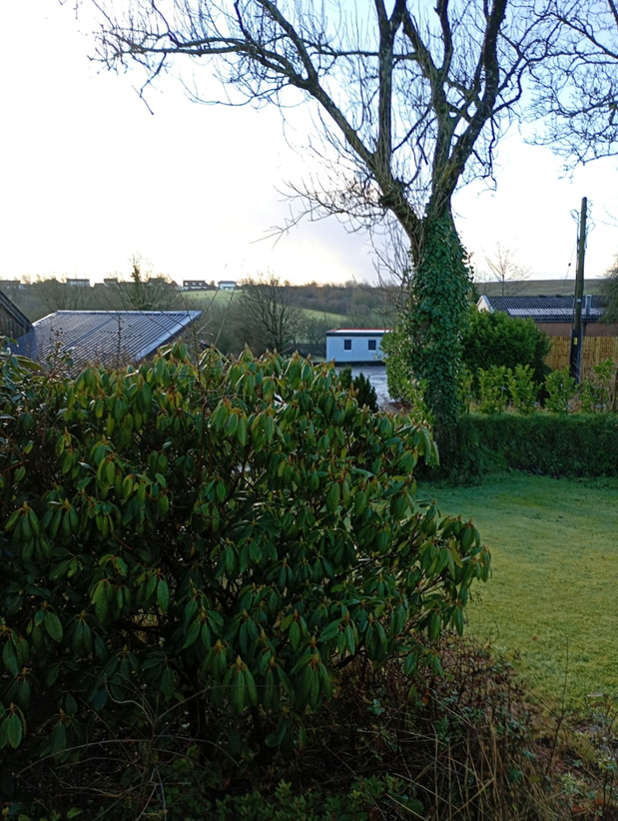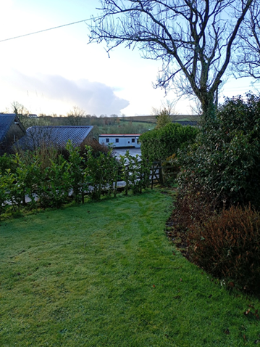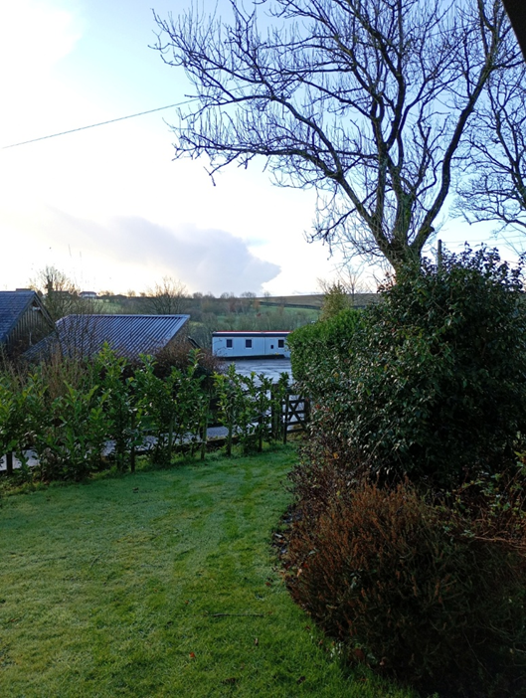
2025/6-78 | Date of next meeting | Date of next meetings in 2026: Mar 19, May 14, July 16, Sept 17, Nov 19
The meeting closed at 19:35
Signed:

